**HANOI-APTECH INTERNATIONAL PROGRAM TRAINING SCHOOL**

**PROJECT REPORT [DURABLE_FUNITURE]**

Project report made by 2 students

Duong Ngo Quang - Student1438159

Oanh Pham Thi Kim – Student1397927

1. Introduction

In modern market where internet’s impact is raising rapidly, archiving success in bussiness require a specific website is necessary for approaching more consumers. This company is going to sell varius type of funiture and decoration so that do marketing by distributing the pamphlets, advertising on television is not enough to reach higher income. Understanding this problem, the company decide to launch a website in order to reach more consumer, provide more necessary informations, support customer more effectively and increase competitive market area. This website is developed by using HTML5, JavaScript and Geolocation and can work effective in almost every most famous browser like Chrome, Firefox, Internet Explorer …

1. Statement of problem

These are some problems when we developing this project together

* Synchronized our style of design

We work well on unified all required function and link them to work well, but each of us has different way of thinking when creating web design. It lead to the different style of design when we unified all web function. Understanding this problem, we decide to hold a group meeting before every update times so that we can fix our design according to an unified idea

* Different in knowedge about developing web

At start, it is difficult to work together because of the different specialize skill. It’s important to devide task so that the project can be complete effectively, after a week working together we finally understand each other skill so that we can decide who would work in which part.

1. User requirements

According to the e-project task the Web site is created base on 8 requirements

1, The Homepage has to be designed using different sections and must have Logo

2, Homepage must contain some information of funitures and decortation, it is also designed with well choosen image that can give customer impressive

3, We also have to create a menu which could show the different type of products consist of available funitures, decorations. Other required information like shop location, email, phone number are listed in footer

4, In each shop page for funitures and decoration, we also have to make a filter so that user can choose types, brands of product they want to see. The detail page of any product is also required to complete so that user can click in any product link, buy button, they can approach more detail information of that product

5, The filter should be work well so that any specific brand selections will display that brand’s product

6, User also require a word document in products detail page that can be download and view

7, A compare page is also created to see the different between two products. It also can compare products in different type and brands

8, We have to make a page called “Contact us” where customer can access to view more detail about the Company, send Email to Company .The detail address of company is displayed using GeoLocation API so that user can feel more comfortable to receive information.

1. Objectives

1, The goal of this project is to help us have a clear example working evironment in real life. By training thorugh this it can help us to find out the way of creating a strong website

2, This e-project is also provide us more knowledge ơf using different tools in creating basic application

3, We also have a review HTML Javascript chapter when we working on this project

1. Scope of the Project

Our porject include these function

* Showing Brand products

This function is basic and the most important requirement, allow customer to see all product and interact with each of them

* Product detail view

This is the next step when user click on any buy button or product link. It give access to customer see more about that product and also provide a word document link to download and see more necessary information

* Filter to categorize as the way user want

It is an important function of the shop web that help customer can access to the products of any various types and brands they want

* Detail information about the company

This the part where user access when they feel want to reach more information in order to have some advice, mailing or any report to the company. It can also help customer find the location of the company so that they can see products realisticly or solve their problems directly .

1. Screen Show

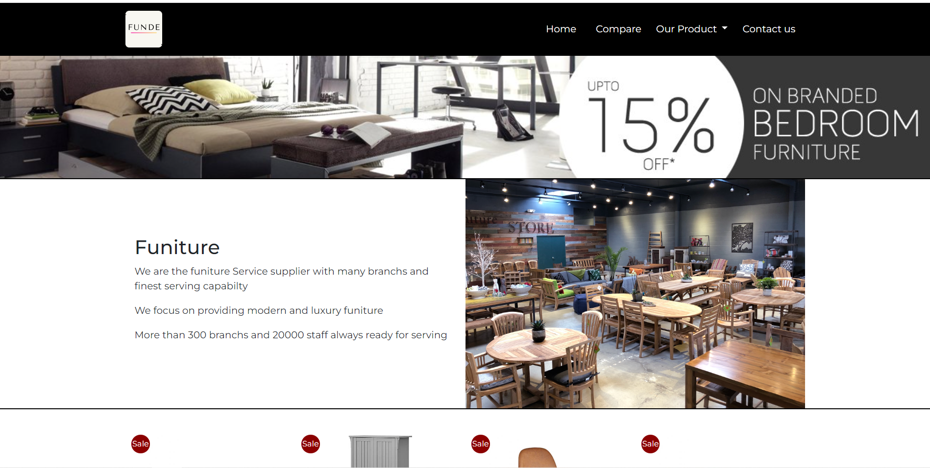

Header

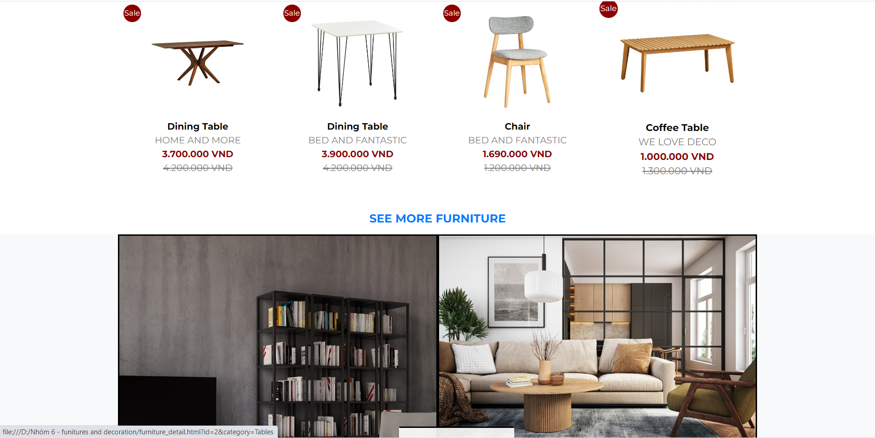

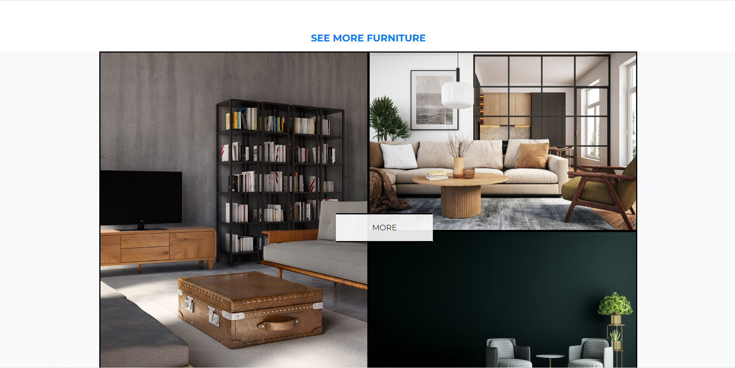

Funitute section of homepage

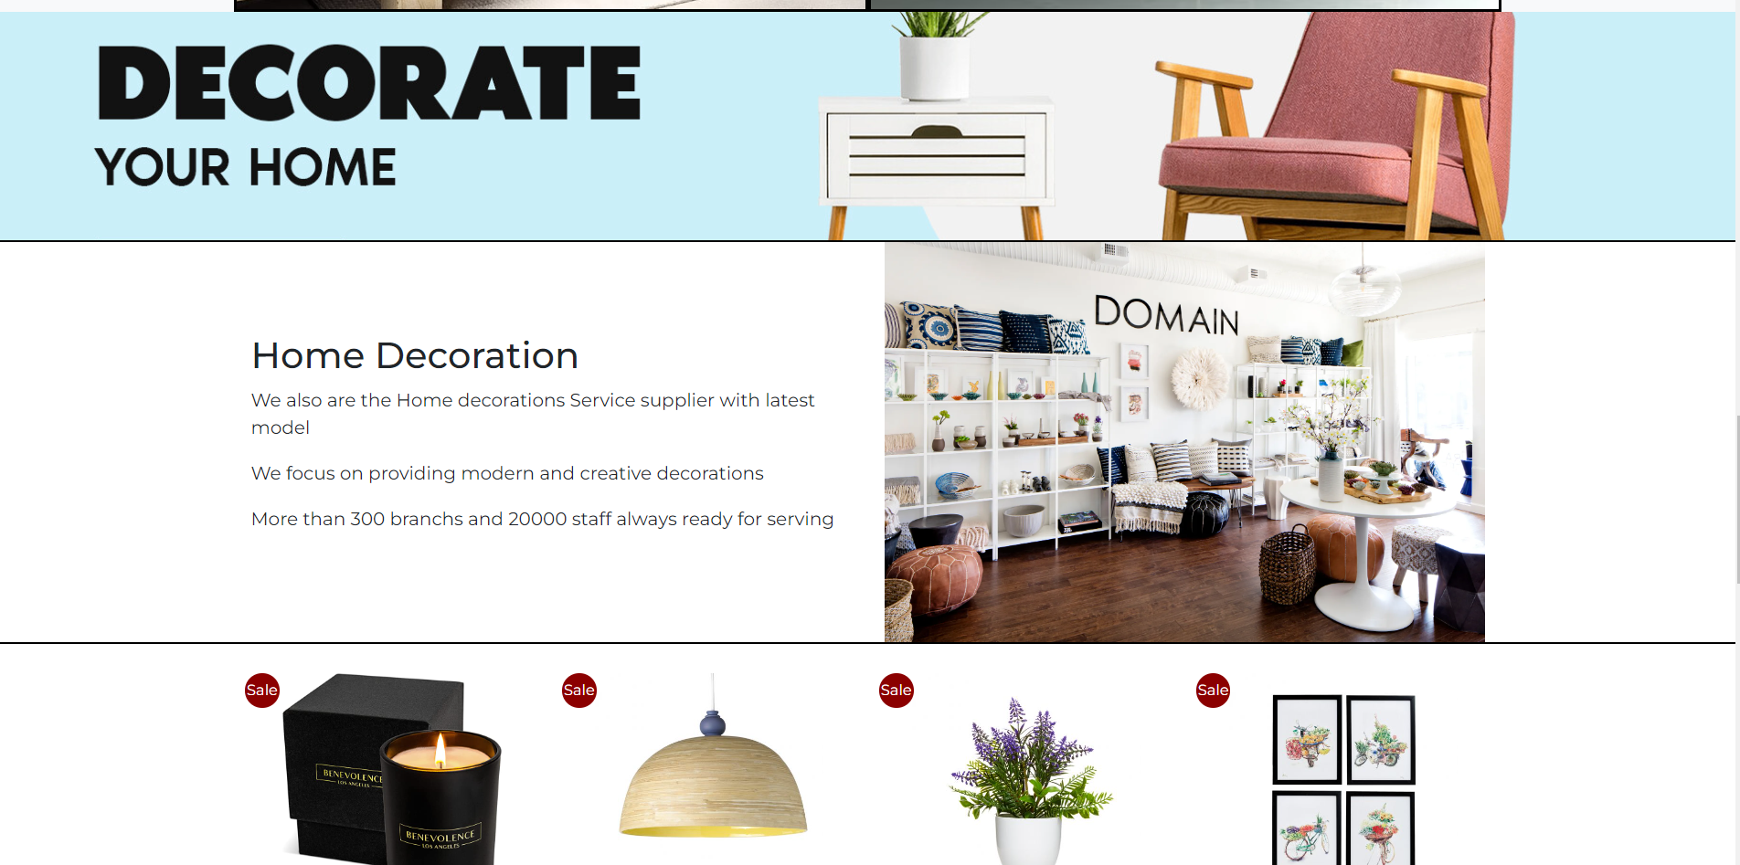

Decoration section of home page

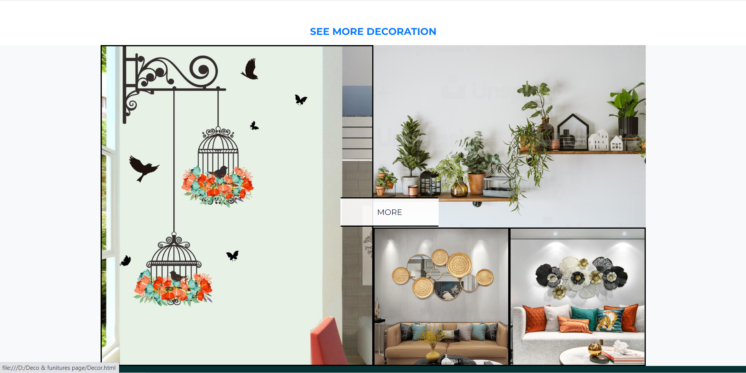

Decoration section of homepage

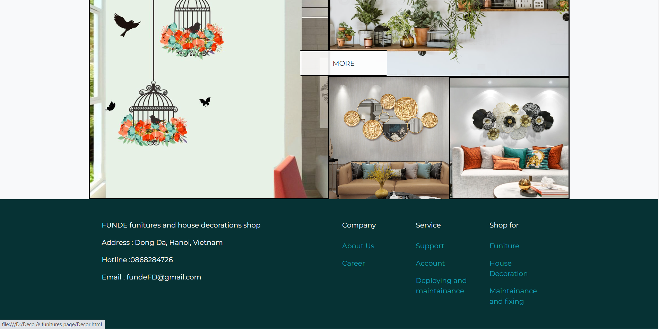

Footer

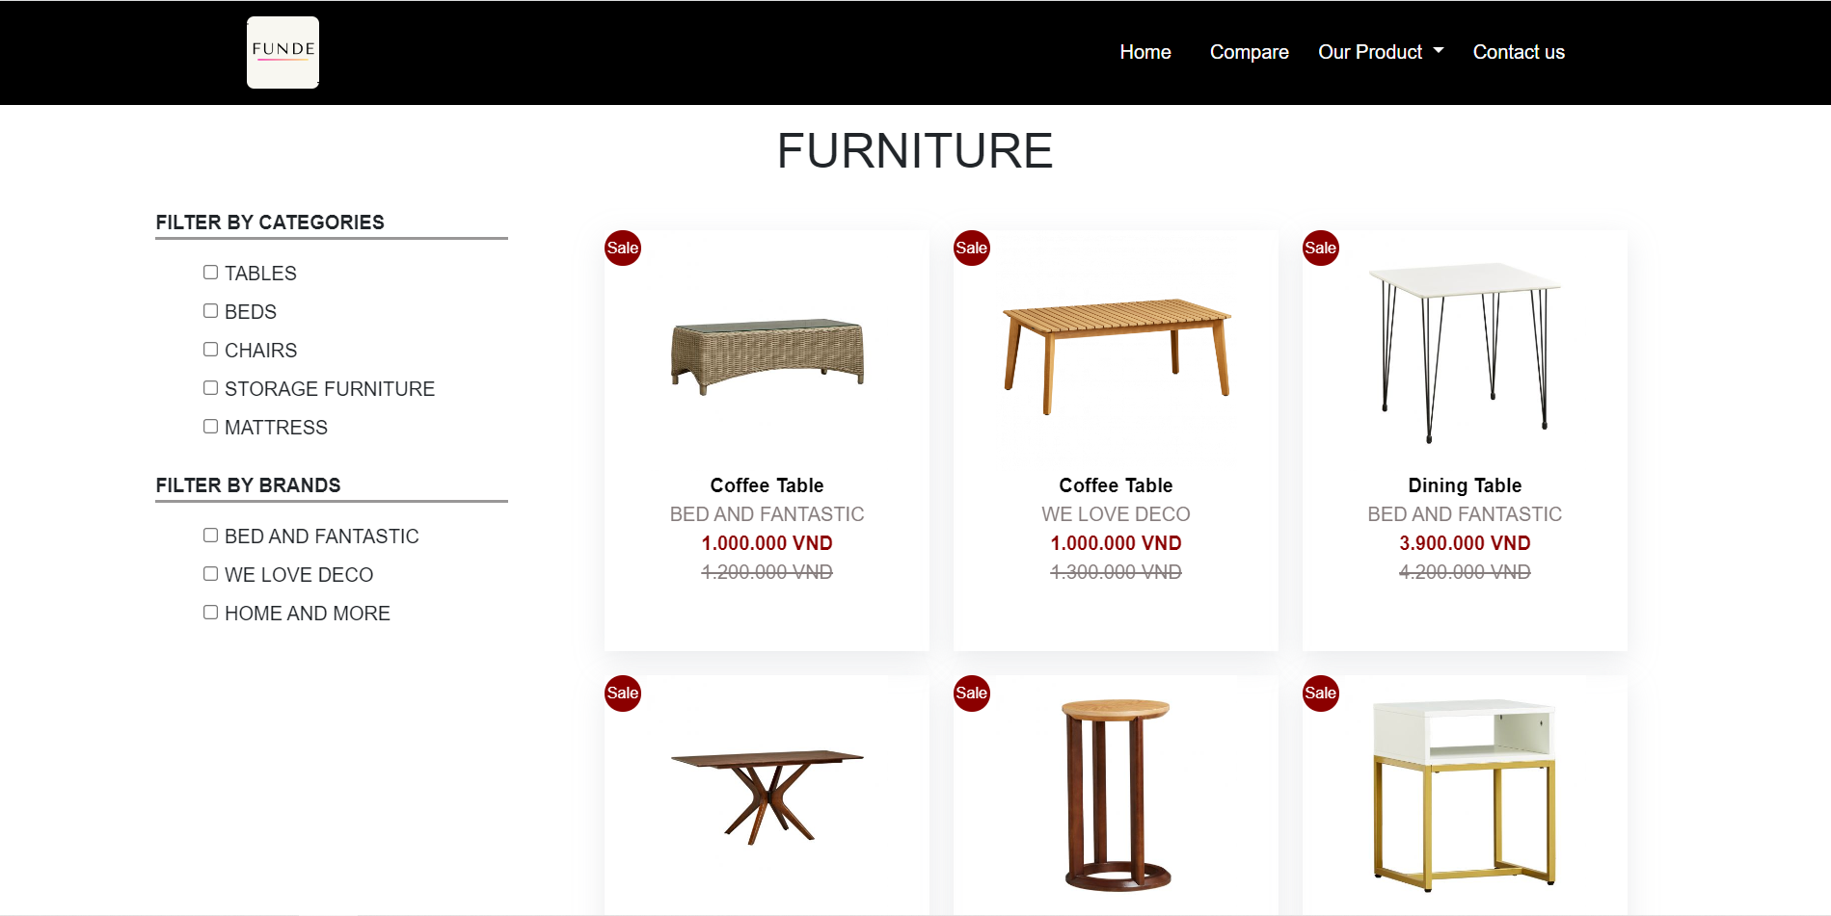

Funiture products list page

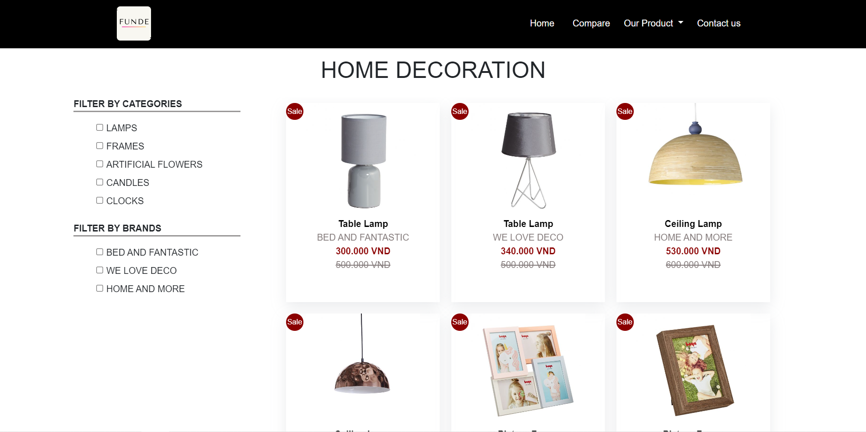

Decoration products list page

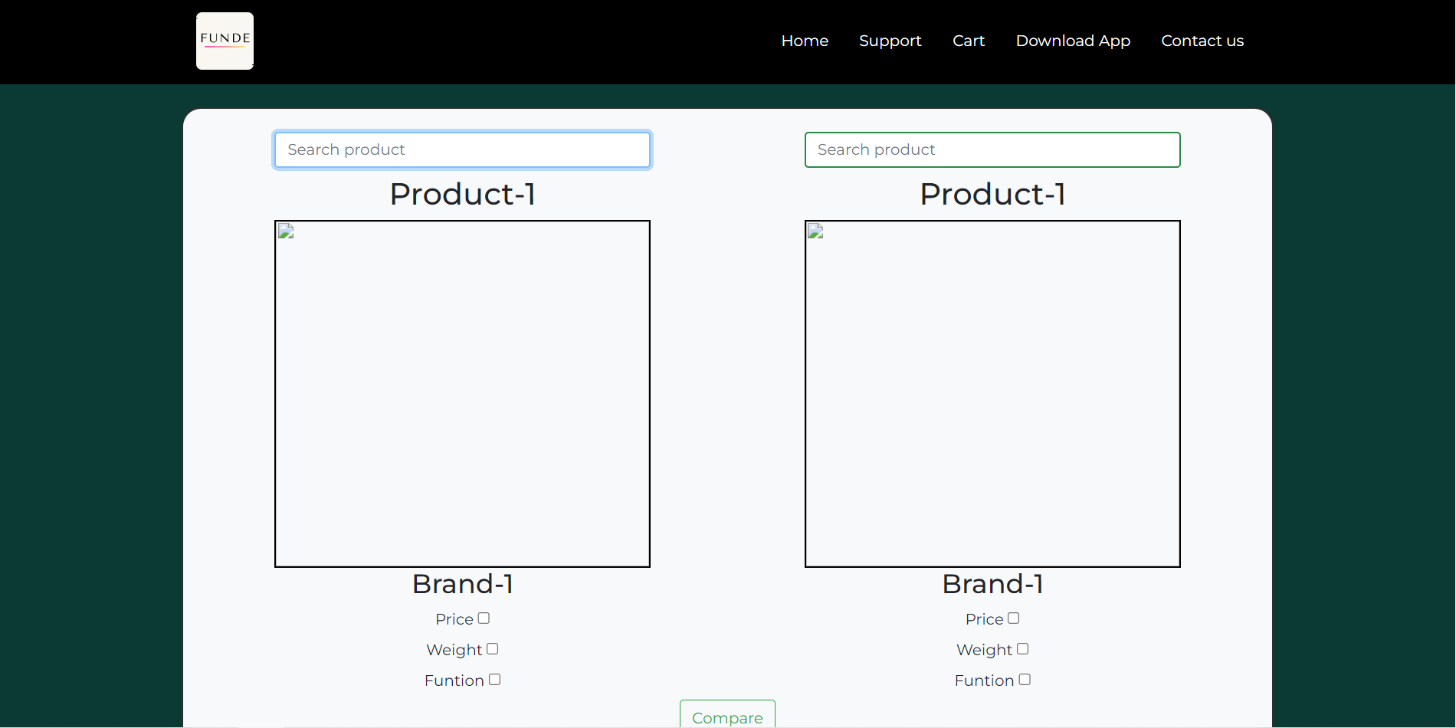

Compare product page

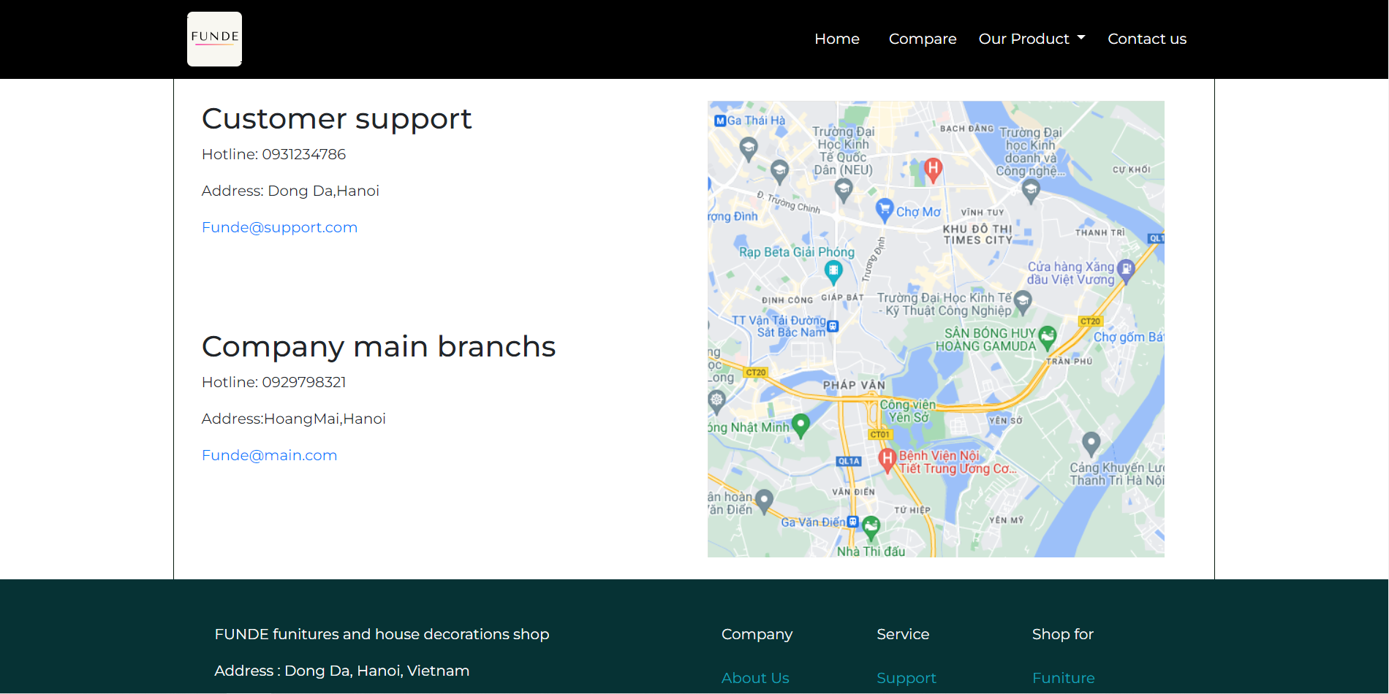

Contact us page

1. User guide

1, The home button is for get back to the homepage

2, Our product will drop down 2 button that are the funiture button and the decoration button. These two button will show the view of products list as their name

3, Contact us will show the Page which contain necessary information about the company

4, Compare button will show the compare page

5, Any image and buy button in the products list will show that product on click

6, Customers can also click any tick boxes on the filter so that they can categorize items as they want